

**American International University- Bangladesh**

**CSC 3215: Web Technologies**

**CO2 and CO4 Evaluation**

**Finished Project Report**

**Fall 2020-2021**

**Project Title: University Management System**

**Section: F**

|  |  |
| --- | --- |
| Student Name | Student Id |
| Borno, Md. Sirajuddin | **18-36449-1** |
| SHAFIQ AHMED | **18-38454-2** |
|  |  |
|  |  |

**Project Description:**

*Our project is University Management System. We choose this project because of 2 main reasons.*

1. *Every university should be using a digital system that does not require much man power and paper-pen. In this way Environment is saved and cost are reduced.*
2. *Ongoing pandemic: On situation like Covid-19 every university has closed their physical campus. So they need a system like this to continue their student’s education.*

*Some of the key features of users are mentioned below:*

* *Admin:*
  + Register new teacher
  + View and Edit teacher, student and stuff profile
  + View System log
* Teacher:
  + View Student Profile
  + Upload study materials
  + Upload grades
* Stuff:
  + Register new student
  + Receive payment
  + Setup classroom
  + Notice update
* Student:
  + View finance
  + View grade
  + Download study material
  + View teacher profile

**Project Folder Structure:**

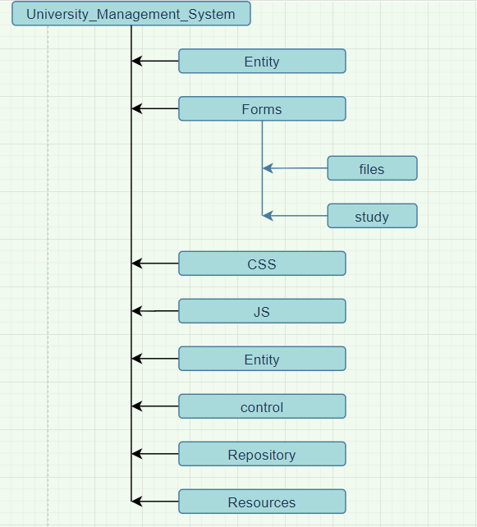

**Core Modules of the Project:**

***Login_check.php***

$cred = new Credential();

        $entity = $cred->Get($login);

        if ($entity != null) {

            $cookie_name = "email";

            $cookie_value = $entity->getEmail();

            setcookie($cookie_name, $cookie_value, time() + (10), "/");

            $_SESSION["email"] = $entity->getEmail();

            $_SESSION["id"] = $entity->getId();

            $_SESSION["UserType"] = $entity->getType();

            if ($entity->getType() == 'teacher') {

*// header("Refresh:0;url= Teacher_Home.php");*

                header("Refresh:0;url= Teacher_Profile.php");

            } else if ($entity->getType() == 'admin') {

                header("Refresh:0;url= AdminProfile.php");

            }

        }

***Teacher_Search.js***

function showTeacher() {

    var uname = document.getElementById("uname").value;

    var xhttp = new XMLHttpRequest();

    xhttp.onreadystatechange = function() {

        if (this.readyState == 4 && this.status == 200) {

            document.getElementById("mytext").innerHTML = this.responseText;

        } else {

            document.getElementById("mytext").innerHTML = this.status;

        }

    };

    xhttp.open("POST", "/University_Management_System/control/Teacher_Search_Control.php", true);

    xhttp.setRequestHeader("Content-type", "application/x-www-form-urlencoded");

    xhttp.send("uname=" + uname);

}

***Credential_repo.php***

<?php

include('DataAccess.php');

class Credential

{

    private $db;

    function __construct()

    {

        $this->db = new DataAccess();

    }

    function Get(Login  $entity)

    {

        $sql2 = "SELECT * FROM login_type WHERE  email='" . $entity->getUsername() . "' OR

        id = '" . $entity->getUsername() . "'  AND password= '" . $entity->getPassword() . "' ";

        $result = $this->db->ReaderQuery($sql2);

        if ($result->num_rows > 0) {

            while ($row = $result->fetch_assoc()) {

                $entity->setId($row["id"]);

                $entity->setEmail($row["email"]);

                $entity->setType($row["type"]);

                return $entity;

            }

        } else {

            return null;

        }

    }

}

|  |  |  |  |  |  |
| --- | --- | --- | --- | --- | --- |
| **CO2 and CO4 Evaluation: Project Report Evaluation** | | | | | |
| **Completeness**  **(5)** | **Validation**  **(5)** | **Feature Implementation**  **(5)** | **Concept Understanding**  **(5)** | **Promptness (5)** | **Total (25)** |
|  |  |  |  |  |  |
|  | | | | | |